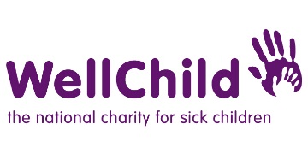
Safeguarding Incident Reporting Form 2:
Reporting concerns about a WellChild staff member, volunteer or associate

Please use this form to summarise the safeguarding concern you have been involved with. This form should be used to report a concern about a WellChild staff member, volunteer of associate. Please see Form 1 for reporting concerns about a child, young person or vulnerable adult.
This form will be used as a front cover so that we can see a summary of concerns and any actions. This will be attached to the front of any relevant e-mails, correspondence, and written records of telephone calls in relation to this concern.
Please complete as much information as you can
Your name

Your job title
(if WellChild employee only)

Your team and line manager
(if WellChild employee only)

Your email address

Your contact telephone details

Date of reported incident or concern

Summary of the incident or concern.
Please include where possible the following information.
Do you have safeguarding concerns about a member of the WellChild staff or a WellChild Volunteer (including Trustees)? | Yes/No
Name of person of concern and connection to WellChild

Please provide any contact details of the above named person (including Address, Email, Tel No)

If applicable - Name and age of any children involved.

If applicable - Date of Birth of child (if known)

If applicable - Details of other children in household (if known)

Nature of contact (e.g. telephone, face to face etc)
Please provide details of the concern being reported.
Was there an immediate risk? | Yes/No
Did you call the police? | Yes/No  If yes, please share any relevant details:
Have you reported to any other external agency/agencies? E.g. Social services, NSPCC, Child Line. | Yes/No  If yes, please share relevant details:

Please complete this form and return to safeguarding@Wellchild.org.uk

